**WEEK 6**

**REACT**

**MANDATORY**

1. **MyfirstReact**

import React from 'react';

function App() {

  return (

    <div>

      <h1>welcome to the first session of React</h1>

    </div>

  );

}

export default App;

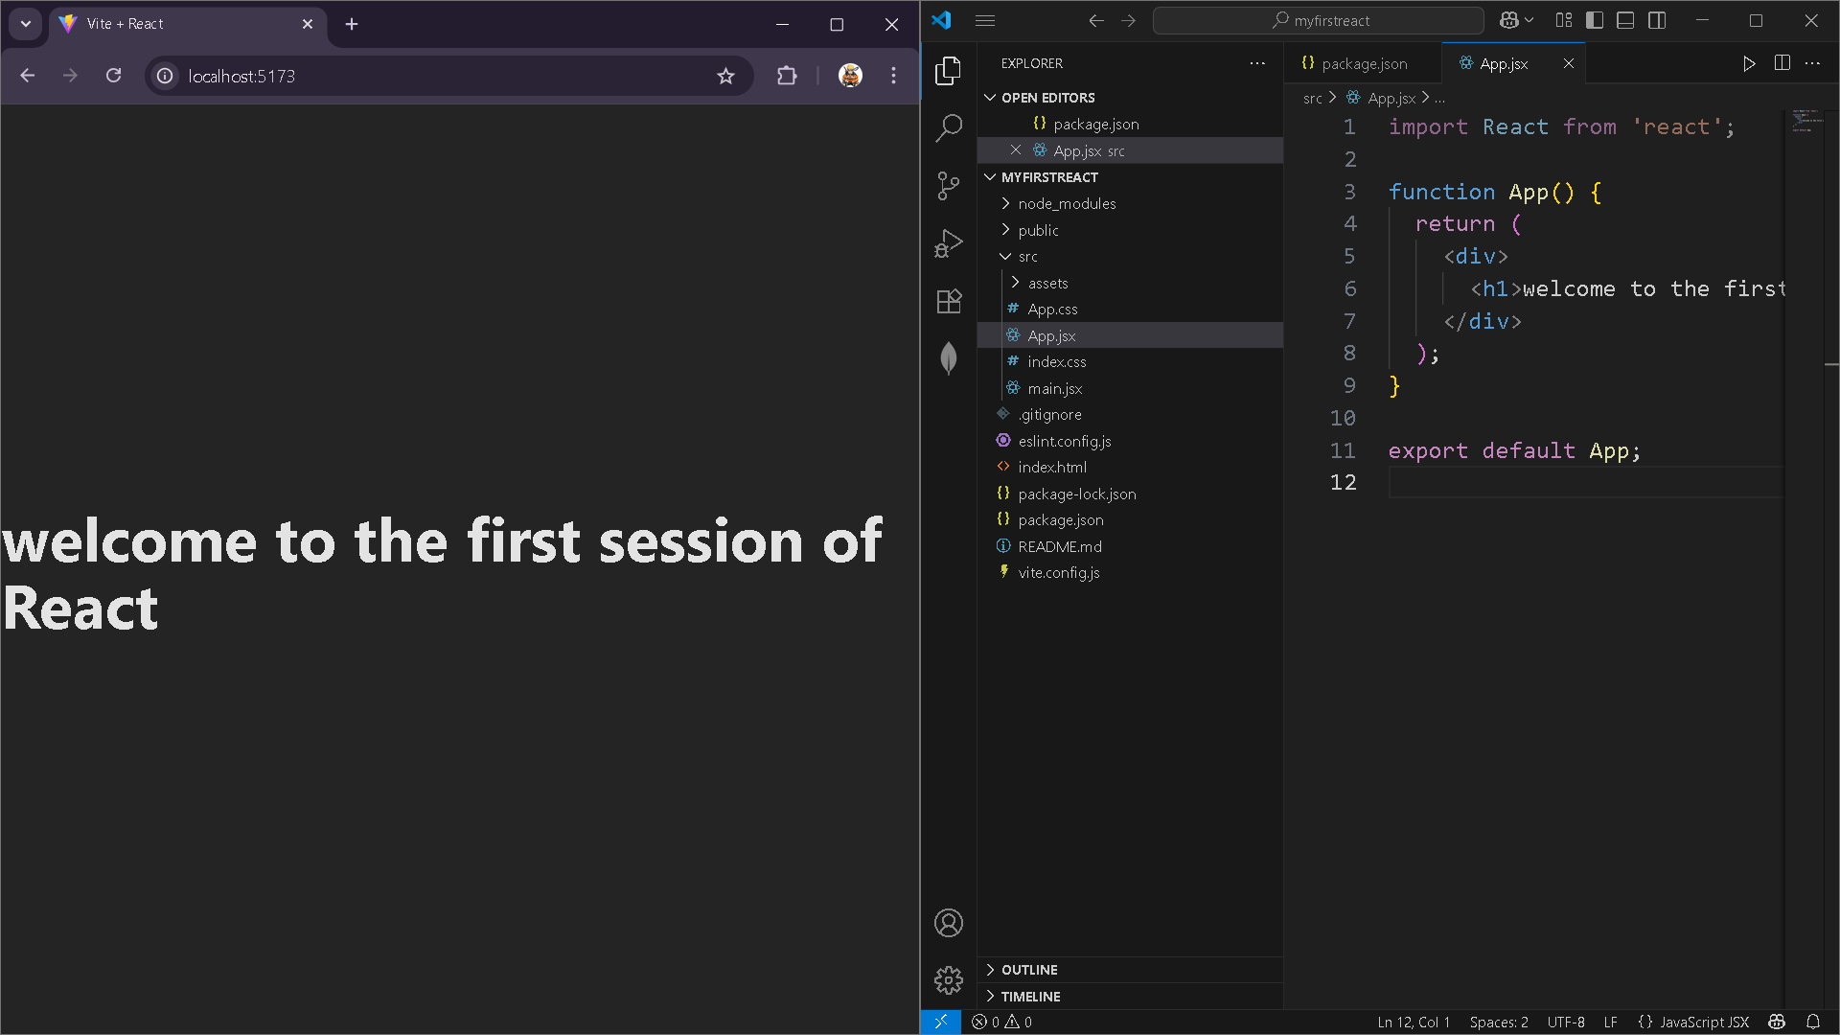

1. StudentApp

Home.jsx

function Home() {

return (

<div>

<h1>Welcome to the Home page of Student Management Portal</h1>

</div>

);

}

export default Home;

About.jsx

function About() {

return (

<div>

<h1>Welcome to the About page of the Student Management Portal</h1>

</div>

);

}

export default About;

Contact.jsx

function Contact() {

return (

<div>

<h1>Welcome to the Contact page of the Student Management Portal</h1>

</div>

);

}

export default Contact;

App.jsx

import Home from './Components/Home';

import About from './Components/About';

import Contact from './Components/Contact';

function App() {

return (

<div>

<Home />

<About />

<Contact />

</div>

);

}

export default App;

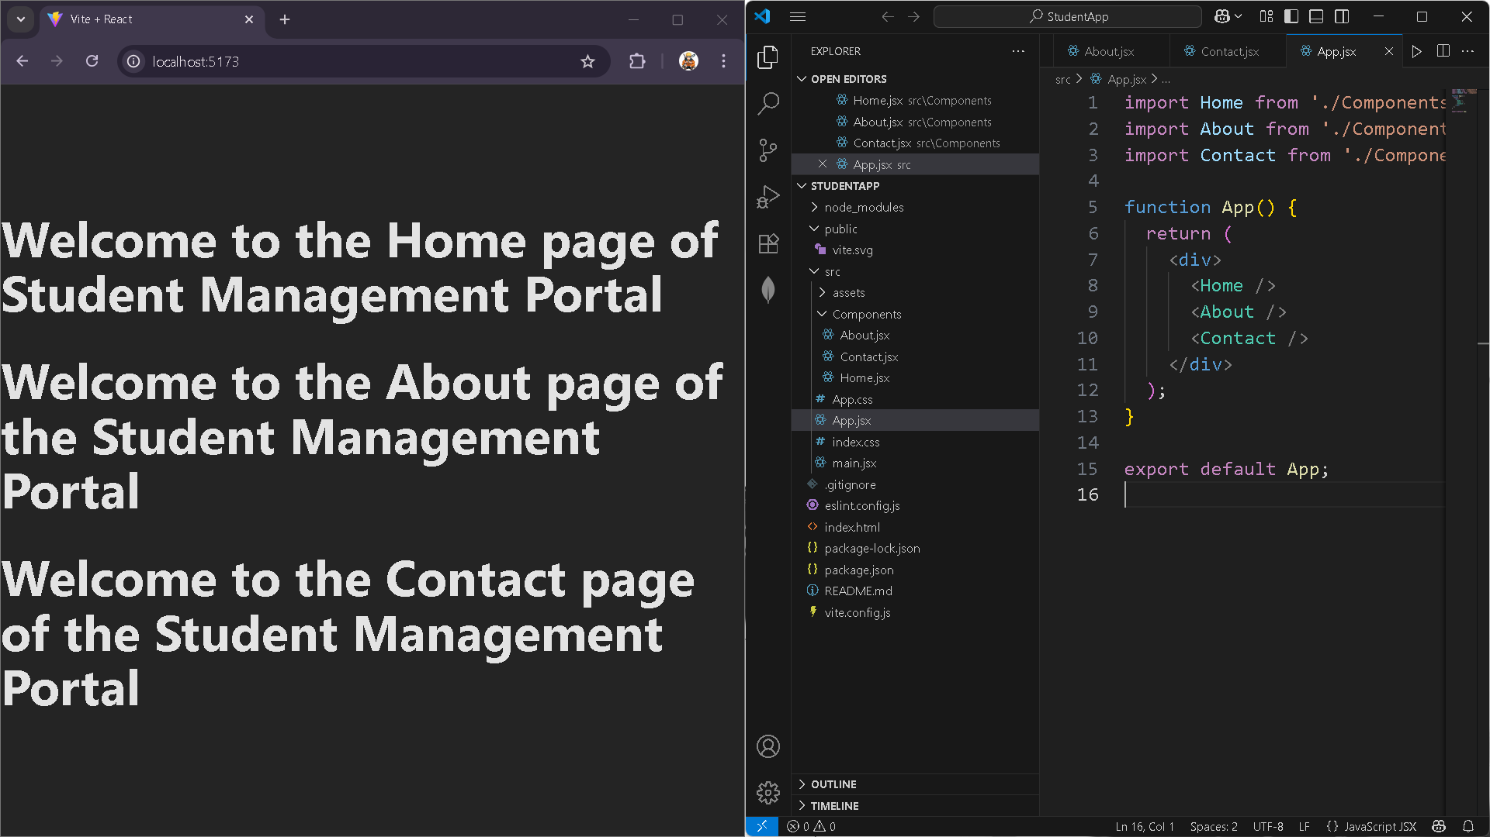

1. **ScoreCalculateApp**

CalculateScore.jsx

import '../Stylesheets/mystyle.css';

const percentToDecimal = (decimal) => {

  return (decimal.toFixed(2) + '%');

};

const calcScore = (total, goal) => {

  return percentToDecimal(total / goal);

};

export const CalculateScore = ({ Name, School, total, goal }) => (

  <div className="formatstyle">

    <h1><font color="Brown">Student Details:</font></h1>

    <div className="Name">

      <b><span>Name: </span></b>

      <span>{Name}</span>

    </div>

    <div className="School">

      <b><span>School: </span></b>

      <span>{School}</span>

    </div>

    <div className="Total">

      <b><span>Total: </span></b>

      <span>{total}</span>

      <span> Marks</span>

    </div>

    <div className="Score">

      <b>Score: </b>

      <span>{calcScore(total, goal)}</span>

    </div>

  </div>

);

Mystyle.css

.Name

{

    font-weight:300;

    color:blue;

}

.School

{

    color:crimson;

}

.Total

{

    color:darkmagenta;

}

.formatsyle

{

    text-align:center;

    font-size:large;

}

.Score

{

    color:forestgreen;

}

App.jsx

import React from 'react';

import {CalculateScore} from './components/CalculateScore';

function App() {

  return (

    <div>

      <CalculateScore Name={"Steeve"}

      School={"DNV Public School"}

      goal={3} />

    </div>

  );

}

export default App;

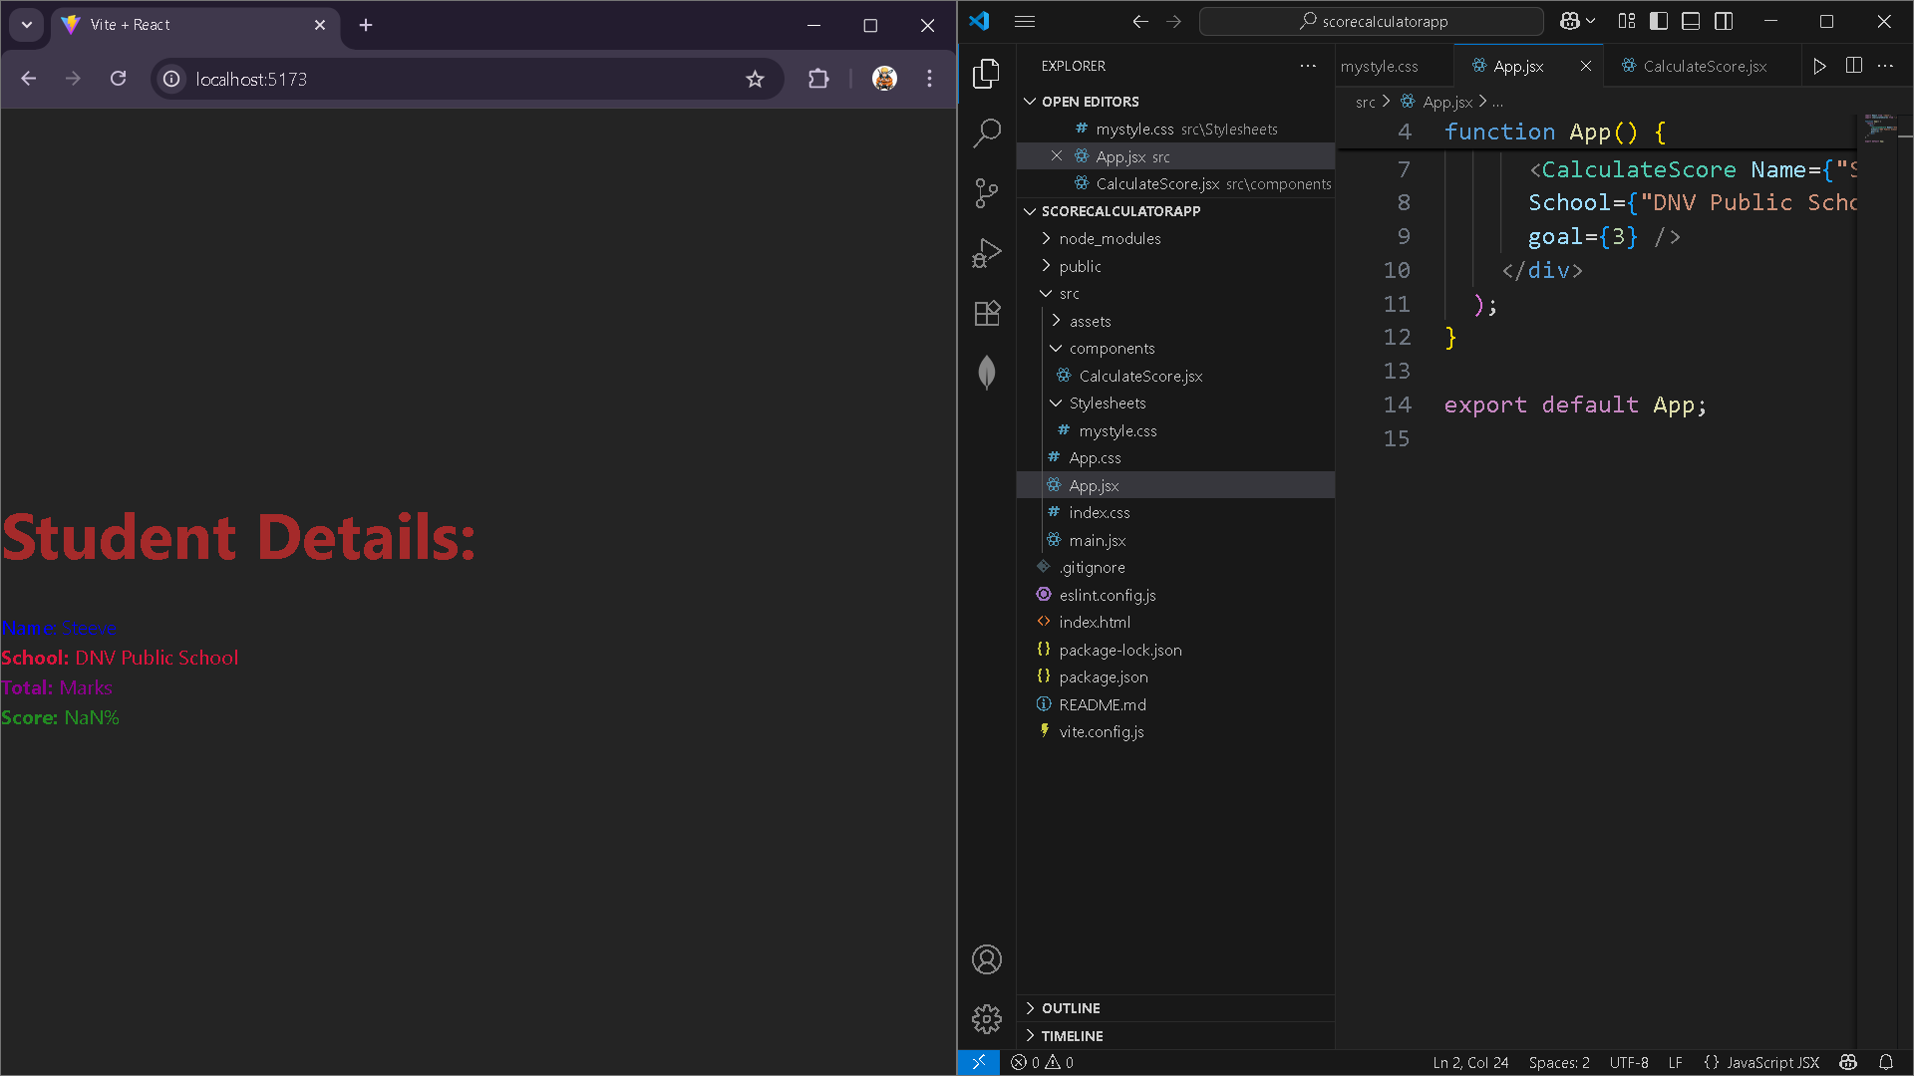

1. **Blogapp**

Post.jsx

class Post {

    constructor(id, title, body){

        this.id=id;

        this.title=title;

        this.body=body;

    }

}

export default Post;

Posts.jsx

import React from 'react';

import Post from './Post';

class Posts extends React.Component {

  constructor(props) {

    super(props);

    this.state = {

      posts: [],

      hasError: false,

      errorMessage: ''

    };

  }

  // Fetch posts using fetch API

  loadPosts() {

    fetch('https://jsonplaceholder.typicode.com/posts')

      .then(response => response.json())

      .then(data => {

        const postObjects = data.slice(0, 5).map(

          post => new Post(post.id, post.title, post.body)

        );

        this.setState({ posts: postObjects });

      })

      .catch(error => {

        console.error("Error fetching posts:", error);

        alert("Error loading posts: " + error.message);

      });

  }

  // Called after component is mounted

  componentDidMount() {

    this.loadPosts();

  }

  // Catch render or lifecycle errors

  componentDidCatch(error, info) {

    console.error("React caught an error:", error, info);

    this.setState({ hasError: true, errorMessage: error.message });

    alert("A rendering error occurred: " + error.message);

  }

  render() {

    if (this.state.hasError) {

      return <h2 style={{ color: 'red' }}>Something went wrong while rendering posts.</h2>;

    }

    return (

      <div>

        <h2>All Posts</h2>

        {this.state.posts.length === 0 ? (

          <p>Loading posts...</p>

        ) : (

          this.state.posts.map(post => (

            <div key={post.id} style={{ marginBottom: '20px' }}>

              <h3>{post.title}</h3>

              <p>{post.body}</p>

              <hr />

            </div>

          ))

        )}

      </div>

    );

  }

}

export default Posts;

app.jsx

import React from 'react';

import Posts from './Posts';

function App() {

  return (

    <div>

      <h1>Blog Application</h1>

      <Posts />

    </div>

  );

}

export default App;

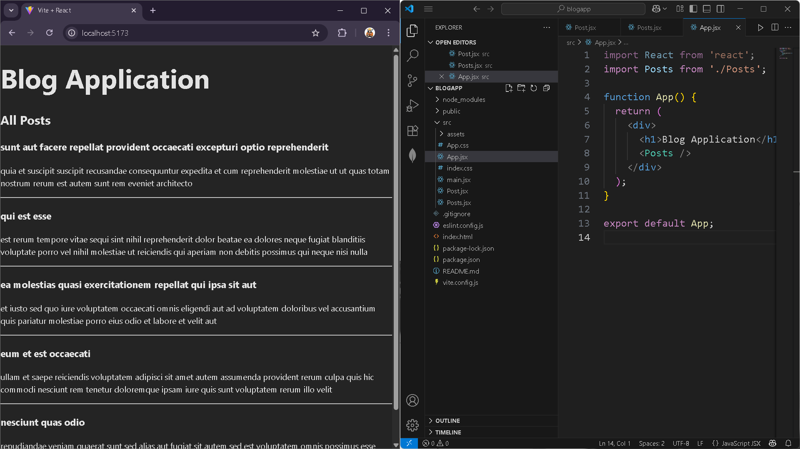

1. **CohortTrackerZip**

cohortDetails.js

import styles from './CohortDetails.module.css';

function CohortDetails(props) {

    return (

        <div className={styles.box}>

            <h3 style={{ color: props.cohort.currentStatus === 'ongoing' ? 'green' : 'blue' }}>

                {props.cohort.cohortCode} -

                <span>{props.cohort.technology}</span>

            </h3>

            <dl>

                <dt>Started On</dt>

                <dd>{props.cohort.startDate}</dd>

                <dt>Current Status</dt>

                <dd>{props.cohort.currentStatus}</dd>

                <dt>Coach</dt>

                <dd>{props.cohort.coachName}</dd>

                <dt>Trainer</dt>

                <dd>{props.cohort.trainerName}</dd>

            </dl>

        </div>

    );

}

export default CohortDetails;

CohortDetails.module.css

/* CohortDetails.module.css */

.box {

  width: 300px;

  display: inline-block;

  margin: 10px;

  padding: 10px 20px;

  border: 1px solid black;

  border-radius: 10px;

}

dt {

  font-weight: 500;

}

